3GPP TSG-RAN WG4 Meeting #119 R4-2605759
Dalian, China, 18th – 22th May 2026

Source: Huawei, HiSilicon
Title: On 6GR Sensing Coexistence
Agenda Item: 8.10.4
Document for: Approval

Introduction
The topic of ISAC (Integrated Sensing and Communication) has been popular since Rel-19. In Rel-20, the Study Item [1] is focused on the performance evaluation of one sensing mode for 5G-A ISAC. According to 6GR Study Item [3], RAN4 is involved in 6G sensing. RAN4 WF [4] [5] was approved in RAN4#116bis /118 with some initial consensus on primary focal points.
In the April meeting, RAN4 identified some scenarios for 6G sensing coexistence study as agreed in [8] from RAN4 work management perspective
- Scenario #1: UAV (passive object), TRP monostatic
- Scenario #2: Vehicle (passive object), TRP-UE bistatic
- Scenario #3: [TBD] (passive object), UE-TRP bistatic
- Scenario #4: UAV (passive object), TRP-TRP bistatic
This contribution provides our views on 6GR sensing coexistence based on some of the scenarios above.

Discussion
The fundamental coexistence to be considered is between sensing and communication system. Currently, it is study stage for 6G and the system design is premature. However, even though 6G is deployed in the future, NR would not be replaced completely in short time. Therefore, NR can be used as the communication system in the co-existence study with sensing.
Proposal 1: Considering it is early stage for 6G study and the system design is premature, NR can be used as the communication system in the coexistence study with sensing.
For sensing mode of TRP monostatic and TRP-UE bistatic, the sensing signal and target reflection are both transmitted in the DL resource in the TDD UL/DL pattern as shown in Figure 1.
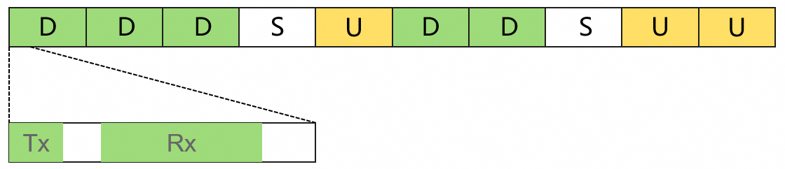
Figure 1 The time domain illustration for sensing
The sensing scenario#1 UAV, TRP monostatic is as shown in Figure 2 (a). The target (UAV) as a node to receive the sensing signal and reflect back to the network. No reception requirements and active transmission from the sensing target. For the coexistence between sensing with TRP monostatic and communication, the sensing target should not be viewed as a victim but an aggressor, due to no reception requirement.
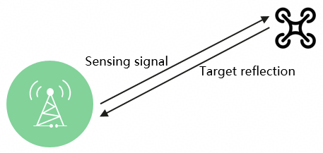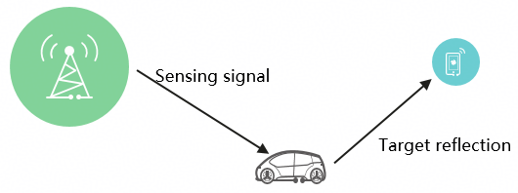
(a) Scenario#1: UAV, TRP monostatic (b) Scenario #2: Vehicle, TRP-UE bistatic
Figure 2 Illustrations of Sensing scenarios
Observation 1: For the coexistence between sensing with TRP monostatic and communication, the sensing target (UAV) should not be viewed as a victim but an aggressor, due to no reception requirement.
The coexistence between sensing in Scenario#1 and communication is illustrated in Figure 3. The interference path to UE as the victim in the communication system is shown with red dash line, and that to sensing system is illustrated with blue dash line. The detailed cases are as follows
Table 1 Coexistence cases for communication system and sensing scenario#1
Sensing mode and sensing target | index | Aggressor | victim
UAV, TRP monostatic | a | Target reflection | NR DL
 | b | Sensing signal | NR DL
 | c | NR DL | Target reflection

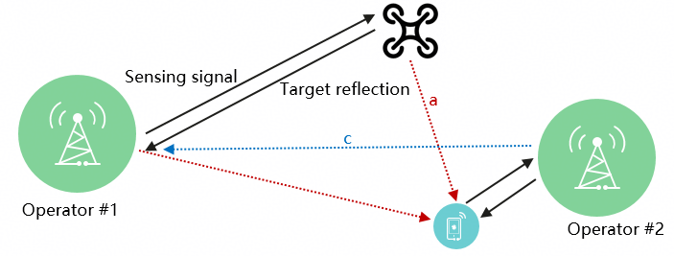
Figure 3 Illustration of coexistence between sensing with scenario #1 and communication
However, the UAV is on the low-altitude, and the height of the device should be assumed different from that for vehicle in scenario#2 in the evaluation.
Proposal 2: For coexistence study, sensing mode of TRP monostatic is considered and starts with the following coexistence cases.
Sensing mode and sensing target | index | Aggressor | victim
UAV, TRP monostatic | a | Target reflection | NR DL
 | b | Sensing signal | NR DL
 | c | NR DL | Target reflection

For sensing scenario#2 Vehicle, TRP monostatic as shown in Figure 2 (b). The target (vehicle) as a node to is also quite similar to the device node in Ambient IoT. If sensing of bi-static between aNB and UE is designed to completely integrated with communication system, for coexistence study, there is no difference for sensing signal involved coexistence from the legacy. It depends on RAN1 discussion. The target reflection should be considered in the path of victim or aggressor.
Observation 2: The target reflection should be considered in the path of victim or aggressor for sensing mode of bi-static between aNB and UE. No need to consider sensing signal in the coexistence study if it is designed to be completely integrated with communication system.
The coexistence between sensing in Scenario#2 and communication is illustrated in Figure 4. The interference path to UE as the victim in the communication system is shown with red dash line, and that to sensing system is illustrated with blue dash line. The detailed cases are as follows
Table 2 Coexistence cases for communication system and sensing scenario#2
Sensing mode and sensing target | index | Aggressor | victim
Vehicles, TRP-UE bistatic | a | Target reflection | NR DL
 | b | Sensing signal | NR DL
 | c | NR DL | Target reflection

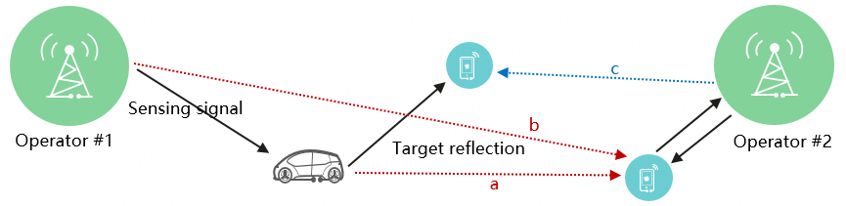
Figure 4 Illustration of coexistence between sensing with scenario #2 and communication
Proposal 3: For coexistence study in RAN4, sensing mode of aNB-UE bi-static is considered and starts with the following coexistence cases, while case (b) need to be further studied and determine the necessity.
Sensing mode and sensing target | index | Aggressor | victim
Vehicles, TRP-UE bistatic | a | Target reflection | NR DL
 | b | Sensing signal | NR DL
 | c | NR DL | Target reflection

In addition, before simulation evaluation, RAN4 need to further analyse case (a) with target reflection as the aggressor in scenario#1 & #2. How much the reflection power level is, and whether the adjacent channel interference to NR DL is too to be considered.
Proposal 4: Before simulation evaluation, RAN4 need to further analyse case (a) with target reflection as the aggressor in scenario#1 & #2 on the reflection power level.
Use cases and sensing modes for 6GR ISAC has been discussed and concluded in RAN plenary with the following progress as described in [6].

5.1.17 Sensing-related requirements
Sensing-related capabilities are measured in terms of the following technical performance requirements:
• Detection Probability and False Alarm Probability: Detection probability is the probability of correctly detecting the presence of the sensing target when it is present, and false alarm probability is the associated probability that a sensing target is detected when no corresponding true sensing target is present.
• Horizontal/Vertical Localization Accuracy: It is defined as the absolute difference between the estimated horizontal/vertical location and the actual horizontal/vertical location of the sensing target. The value of localization accuracy shall be obtained assuming 90% confidence level, which is the 90th percentile point of the CDF of the location estimation error. Both the horizontal and vertical localization accuracy are estimated based on Cartesian coordinates.
• Velocity Accuracy: It is defined as the absolute difference between the estimated velocity and the actual velocity of the sensing target. The value of velocity accuracy shall be obtained assuming 90% confidence level, which is the 90th percentile point of the CDF of the velocity estimation error.
In the above technical performance requirements, the sensing target is a passive object, which is not connected to the radio network for communication.
The minimum requirements for Sensing-related requirements are summarized in Table 5.1.17-1.
Table 5.1.17-1: Sensing-related requirements
 | Indoor Factory | Urban Macro
Detection Probability | 95% | 95%
False Alarm Probability | 5% | 5%
Horizontal Localization Accuracy | 2 m | 5 m
Vertical Localization Accuracy | N/A | 8 m (Note 1)
Velocity Accuracy | 2 m/s | 4 m/s

5.4.4 Sensing
The 6GR and 6G RAN architecture shall at least support use cases of
- detection and/or tracking of passive objects, at least including UAVs, human, vehicles and AGVs
- communication assistance.

In the coexistence study with target reflection as the victim, the metrics of legacy coexistence study 5% throughput loss as final interference evaluation criteria cannot be utilized, especially for the TRP monostatic mode applying pulse/wave signal. RAN4 should consider update the coexistence metrics for sensing, and to start with the KPI as agreed in RANP.
Proposal 5: The metrics of coexistence evaluation
- For the cases with communication system as the victim, the metrics of legacy coexistence study 5% throughput loss as final interference evaluation criteria can be utilized.
- For the cases with sensing related signal/channel as the victim, the KPI for sensing agreed in RAN plenary shall be referred to. And start with
  - Detection Probability
  - False Alarm Probability

Conclusion
This contribution provides our consideration on sensing for 6G ISAC coexistence.
Observation 1: For the coexistence between sensing with TRP monostatic and communication, the sensing target (UAV) should not be viewed as a victim but an aggressor, due to no reception requirement.
Observation 2: The target reflection should be considered in the path of victim or aggressor for sensing mode of bi-static between aNB and UE. No need to consider sensing signal in the coexistence study if it is designed to be completely integrated with communication system.
Proposal 1: Considering it is early stage for 6G study and the system design is premature, NR can be used as the communication system in the coexistence study with sensing.
Proposal 2: For coexistence study, sensing mode of TRP monostatic is considered and starts with the following coexistence cases.
Sensing mode and sensing target | index | Aggressor | victim
UAV, TRP monostatic | a | Target reflection | NR DL
 | b | Sensing signal | NR DL
 | c | NR DL | Target reflection
Proposal 3: For coexistence study in RAN4, sensing mode of aNB-UE bi-static is considered and starts with the following coexistence cases, while case (b) need to be further studied and determine the necessity.
Sensing mode and sensing target | index | Aggressor | victim
Vehicles, TRP-UE bistatic | a | Target reflection | NR DL
 | b | Sensing signal | NR DL
 | c | NR DL | Target reflection
Proposal 4: Before simulation evaluation, RAN4 need to further analyse case (a) with target reflection as the aggressor in scenario#1 & #2 on the reflection power level.
Proposal 5: The metrics of coexistence evaluation
- For the cases with communication system as the victim, the metrics of legacy coexistence study 5% throughput loss as final interference evaluation criteria can be utilized.
- For the cases with sensing related signal/channel as the victim, the KPI for sensing agreed in RAN plenary shall be referred to. And start with
  - Detection Probability
  - False Alarm Probability

References
[1] RP-253246, Revised SID: Study on Integrated Sensing And Communication (ISAC) for NR, Xiaomi, China Telecom, RANP#110
[2] R1-2508733, Overview of 6GR air interface, Huawei, HiSilicon, RAN1#123.
[3] RP-253876, Revised SID: Study on 6G Radio, NTT DOCOMO, CMCC, AT&T, Vodafone, RANP#110
[4] R4-2514592, WF on 6G sensing, ZTE Corp., RAN4#116bis
[5] R4-2602286, WF on 6G sensing, ZTE Corporation, RAN4#118, Gothenburg, SE, 09th–13th, Feb, 2026
[6] TR38.914 v0.4.0
[7] R1-2601944, Sensing integration with communication, Huawei, HiSilicon, RAN1#124bis, St Julian’s, Malta, April 13-17, 2026
[8] R4-2605009, Way Forward for [118bis][362] 6G_Sensing, RAN4#118bis, St Julian’s, Malta, April 13-17, 2026

